**Bài 1:**

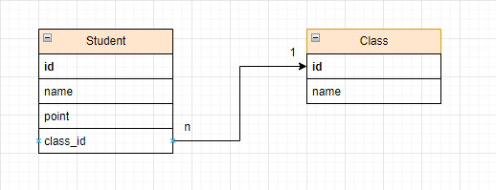

create database bai1;

use Bai1;

create table Student(

id int not null auto_increment primary key,

name varchar(255),

point int,

idClass int

);

create table Class(

id int not null auto_increment primary key,

name varchar(255)

);

alter table Student

add foreign key (idClass) references Class(id);

**Bài 2:**

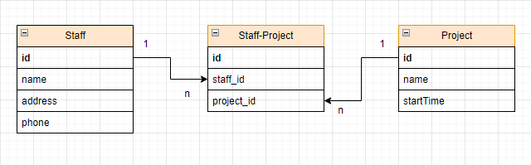

create database bai2;

use bai2;

create table staff(

id int not null auto_increment primary key,

name varchar(255),

address varchar(255),

phone long

);

create table project(

id int not null auto_increment primary key,

name varchar(255),

startTime time

);

create table staff_project(

id int not null auto_increment primary key,

staff_id int,

foreign key (staff_id) references staff(id),

project_id int,

foreign key (project_id) references project(id)

)

**Bài 3:**

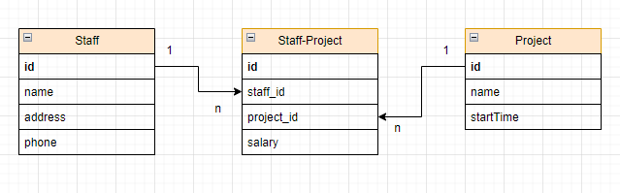

create database bai3;

use bai3;

create table staff(

id int not null auto_increment primary key,

name varchar(255),

address varchar(255),

phone long

);

create table project(

id int not null auto_increment primary key,

name varchar(255),

startTime time

);

create table staff_project(

id int not null auto_increment primary key,

staff_id int,

foreign key (staff_id) references staff(id),

project_id int,

foreign key (project_id) references project(id),

salary long

)